旅遊指南

Tourist Info

在這個專案裡，你會做一隻手機版旅遊指南機器人，這個機器人會推薦遊客可以去哪些景點遊玩。

In this project you will make a mobile Tourist Information bot that makes recommendations to tourists about which attractions they should visit.

你會訓練一個機器學習模型，機器人會學習從旅客的興趣推薦旅遊地點。

You’ll train a machine learning model so the bot can learn to make recommendations based on what people say they’re interested in.

你也會學到機器學習領域中的『偏差』(bias)效應，並觀察這種現象如何發生。

You’ll also learn about the effect of “bias” on machine learning projects and see how this can happen.

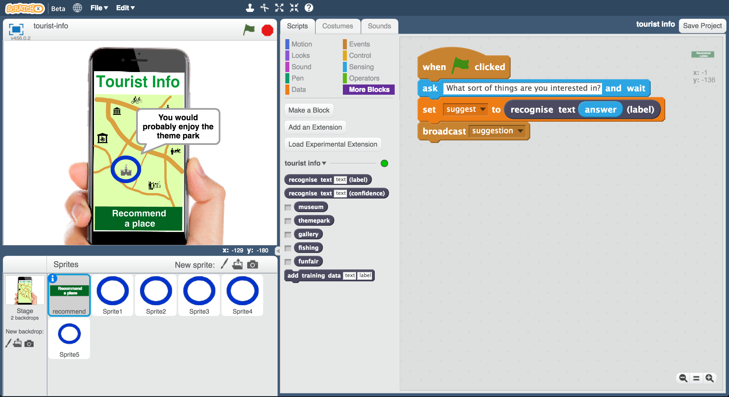

This project worksheet is licensed under a Creative Commons Attribution Non-Commercial Share-Alike License

http://creativecommons.org/licenses/by-nc-sa/4.0/

1. 搜尋網頁：<https://machinelearningforkids.co.uk/>

Go to <https://machinelearningforkids.co.uk/> in a web browser

1. 點選“**Get started**”按鈕

Click on “**Get started**”

1. 點選“**Log In**”按鈕並登入系統

*如果你沒有帳號，請你的老師幫你建立一個帳號。*

Click on “**Log In**” and type in your username and password  
*If you don’t have a username, ask your teacher or group leader.*

1. 點選上方清單中的 **”Projects”** 按鈕

Click on “**Projects**” on the top menu bar

1. 點選 “**+ Add a new project**” 按鈕

Click the **“+ Add a new project**” button.

1. 將你的專案命名為 “tourist info”並設定成辨識 “**text**”類別，點

選 “**Create**”按鈕

Name your project “tourist info”. Set it to learn how to recognise “**text**”. Click “**Create**”  
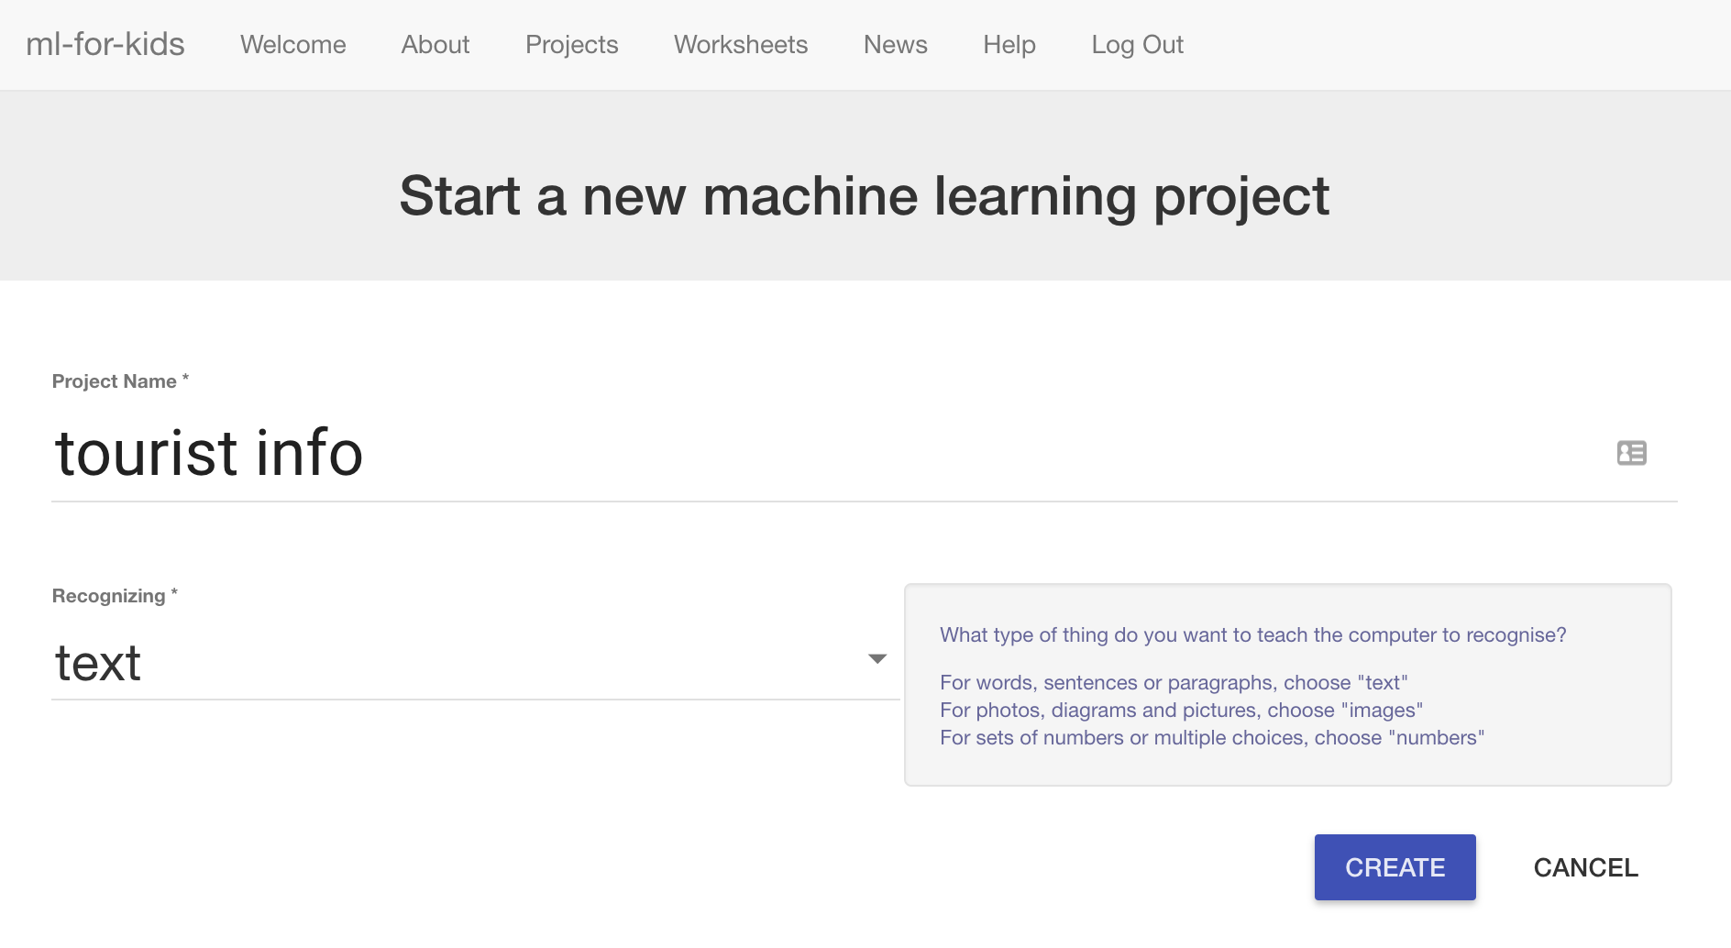

1. 你會在專案清單中看到“**tourist info**”，點選此專案

You should see “**tourist info**” in the list of your projects. Click on it.  
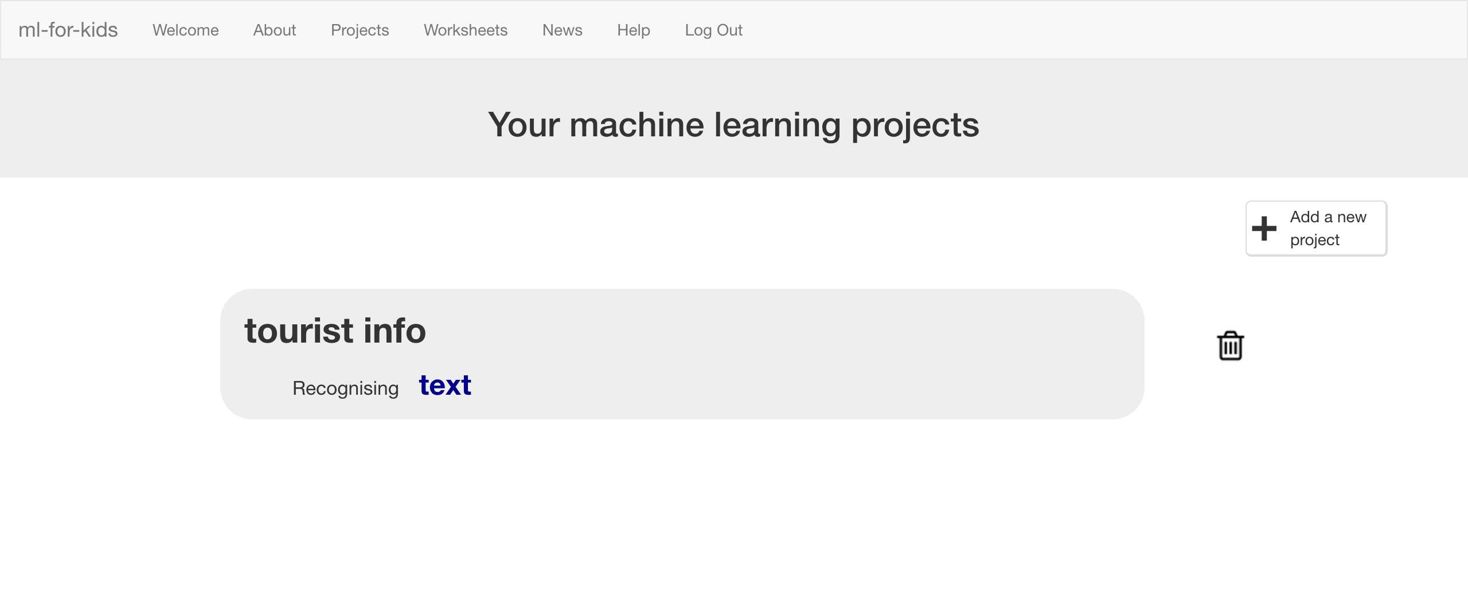

1. 我們從Scratch已有的專案開始，點選“**Make**”按鈕

Start by getting a project ready in Scratch. Click the “**Make**” button.  
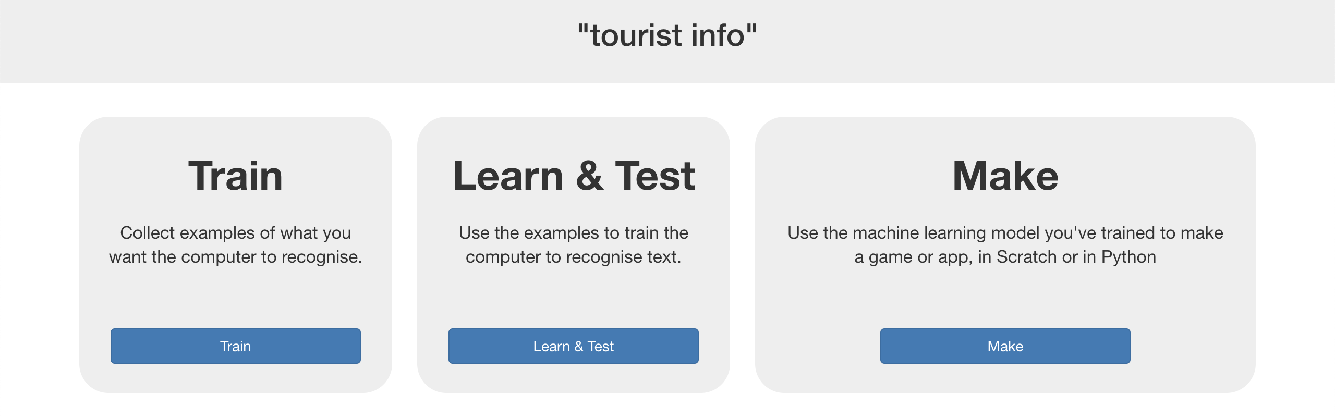

1. 點選“**Scratch**”

Click “**Scratch**”  
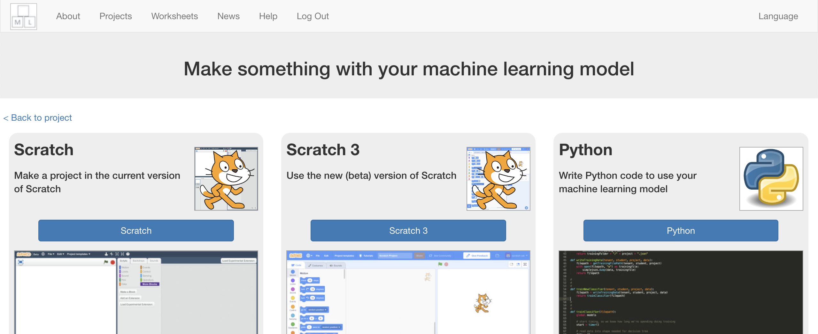

1. 頁面會顯示警告，提醒你還沒有進行任何機器學習。

點選**Scratch by itself。**

The next page will warn you that you haven’t done any machine learning yet. Click on **Scratch by itself** to launch Scratch anyway.   
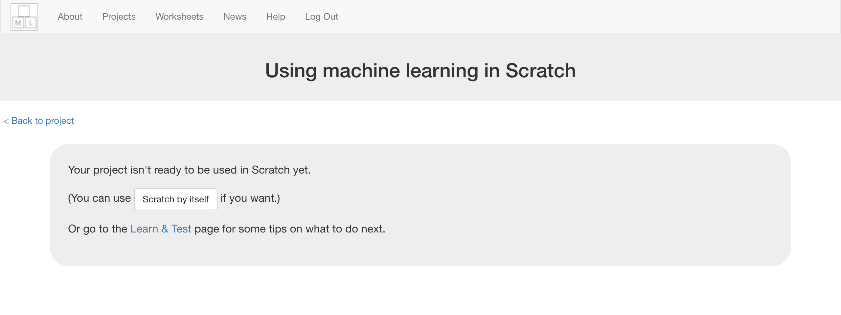

1. 載入**Tourist Info (short)** 專案

*點選****Project templates*** *->再選擇****Tourist Info (short)***

Open the **Tourist Info (short)** template project   
*Click on* ***Project templates*** *->* ***Tourist Info (short)***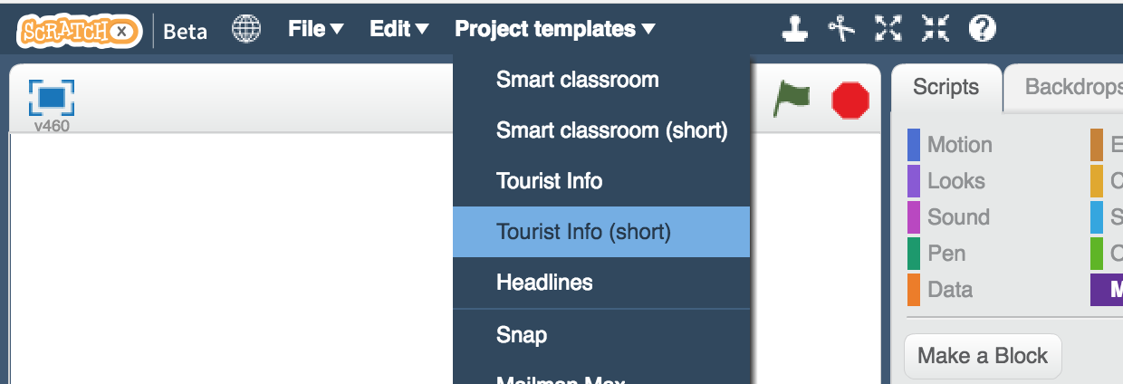

1. 點擊綠旗，進行測試

*輸入你想在假期做的事，輸入完畢按下Enter*

Click the green flag to try it out  
*Type something you like to do on holiday, and press Enter.*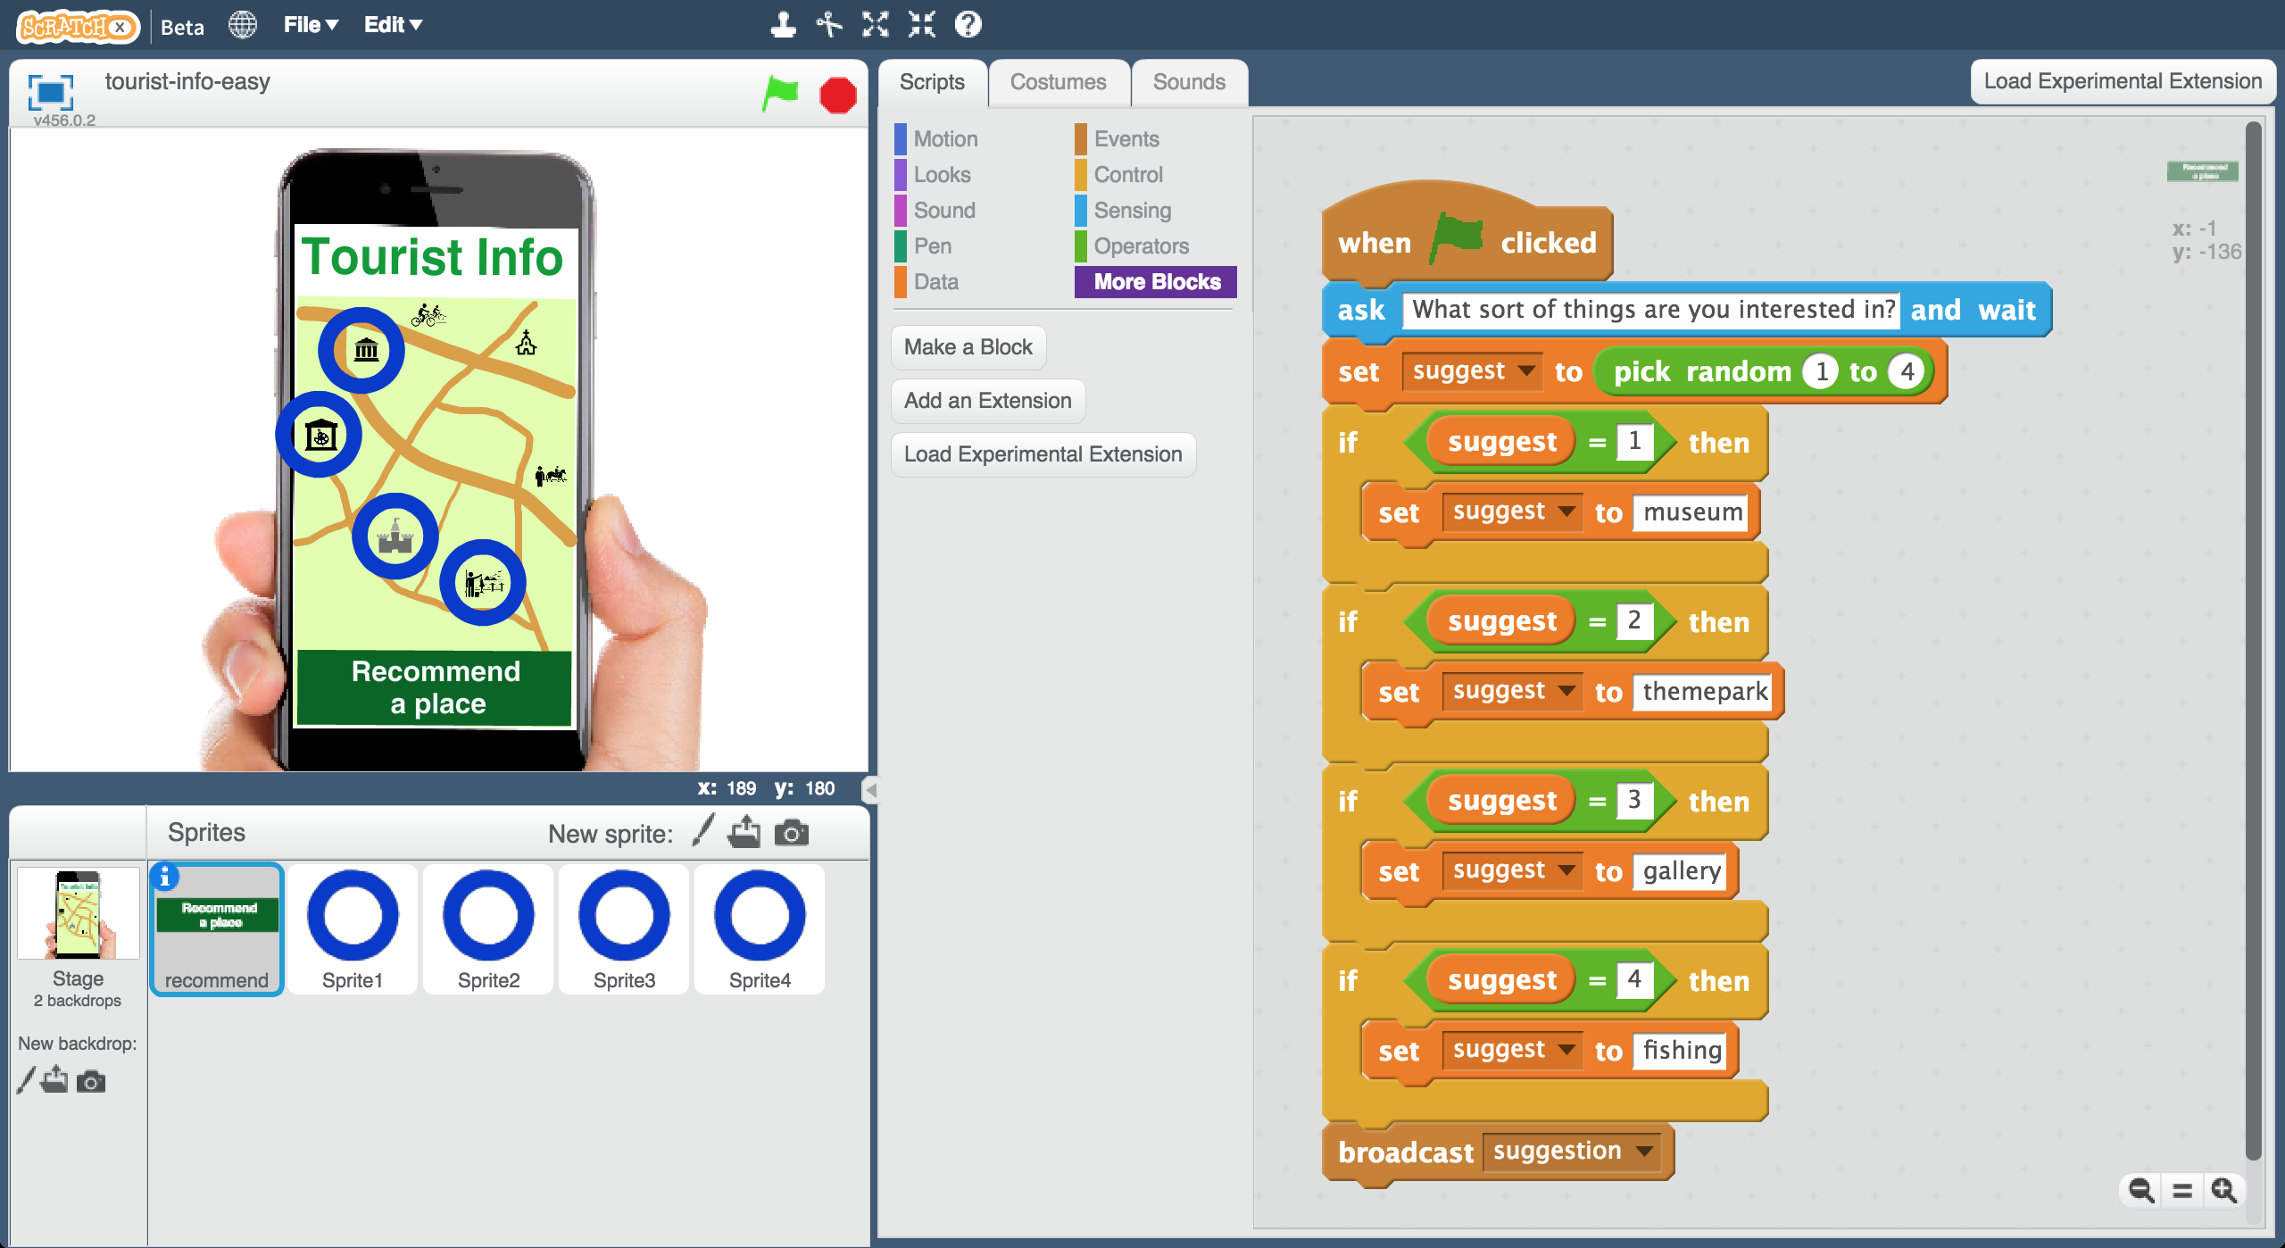

1. 你能說出App是如何幫你挑選景點的嗎？

*觀察角色 “recommend” 的程式碼，你能看出電腦是如何幫你選擇旅遊地點的嗎？如果你不確定，可以問你的老師。*

Can you tell how the app is choosing what to recommend to you?   
*Have a look at the script on the “recommend” sprite. Can you see how it’s choosing holiday destinations? Ask your group leader if you’re not sure.*

1. 關閉Scratch

Close the Scratch window

**到目前為止，你做了哪些事情？**

**What have you done so far?**

這隻手機版的旅遊指南機器人能推薦旅客遊玩景點。首先，他會問旅客對什麼有興趣，然後依照每個人的興趣推薦不同的景點。

不過，到目前為止，機器人只是隨機挑選地點而已。

This is a mobile Tourist Information bot that will make recommendations to visitors. It will ask them what they’re interested in, so it can make the best recommendation. But for now, it’s choosing something at random.

你需要訓練機器人使用機器學習來推薦。

我們希望可以訓練它，讓它真的有能力進行推薦，所以我們會把機器學習加入機器人中。

You need to train it to be able to make recommendations, so you can use machine learning in your bot.

1. 我們需要一些範例來訓練電腦。點選“**< Back to project**”，再點選**Train**按鈕

We need examples to train the computer. Click the **“< Back to project**” link. Then click the **Train** button.   
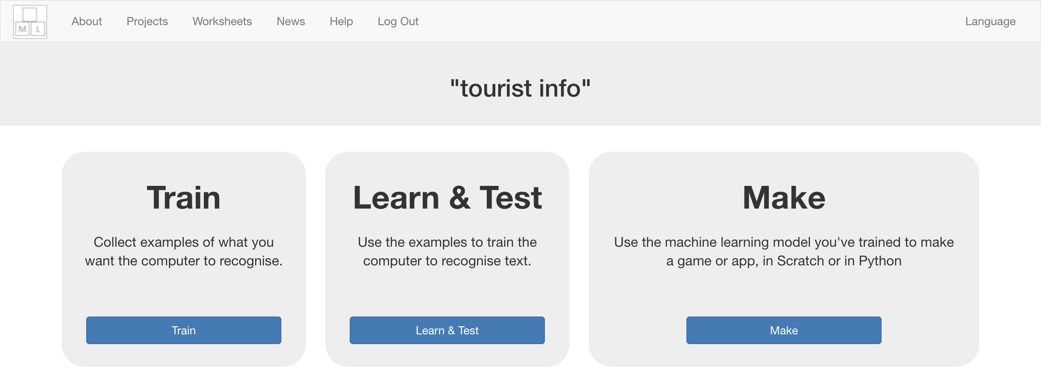

1. 點選**“+ Add new label**”，加入四個方框，分別命名為：“museum”、 “themepark”、 “gallery”和“fishing”。

Click on **“+ Add new label**” and call it “museum”.   
Do that again, and create a second bucket called “themepark”.  
Create a third bucket called “gallery” and a fourth called “fishing”.  
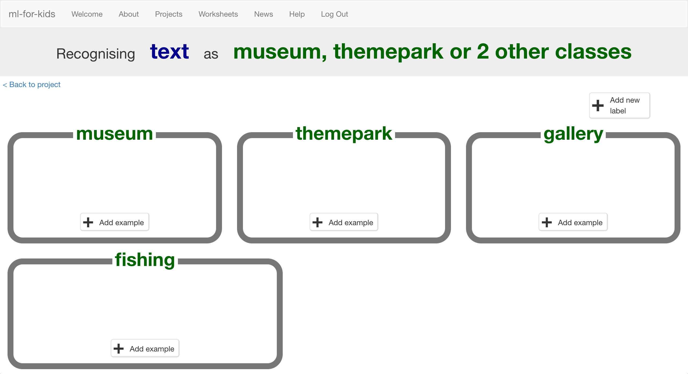

1. 點選“museum”方框中的“**Add example**”按鈕，輸入對博物館有興趣的旅客可能會說的話。

*舉例來說，你可以輸入：“I like to learn about history while I’m on holiday!”*

Click the “**Add example**” button in the “museum” bucket, and type in something a tourist who would like a museum might say.  
*For example: “I like to learn about history while I’m on holiday!”*

1. 點選“themepark”方框中的“**Add example**”按鈕，輸入對主題樂園有興趣的旅客可能會說的話。

*舉例來說，你可以輸入：“I want to do something exciting that gets my heart going”*

Click the “**Add example**” button in the “themepark” bucket, and type in something a tourist who would like theme parks might say.  
*For example: “I want to do something exciting that gets my heart going”*

1. 點選“gallery”方框中的“**Add example**”按鈕，輸入對畫廊有興趣的旅客可能會說的話。

*舉例來說，你可以輸入：“I want to do something cultural and I enjoy art”*

Click the “**Add example**” button in the “gallery” bucket, and type in something a tourist who would like galleries might say.  
*For example: “I want to do something cultural and I enjoy art”*

1. 點選“fishing”方框中的“**Add example**”按鈕，輸入對釣魚有興趣的旅客可能會說的話。

*舉例來說，你可以輸入：“I’m looking for a chance to relax and I’d like to do something quiet”*

Click the “**Add example**” button in the “fishing” bucket, and type in something a tourist who would like fishing might say.  
*For example: “I’m looking for a chance to relax and I’d like to do something quiet”*

1. 重複步驟17~21直到每個方框都有**5個**範例句子

Repeat steps 17 – 20 until you’ve written **five** examples of each.  
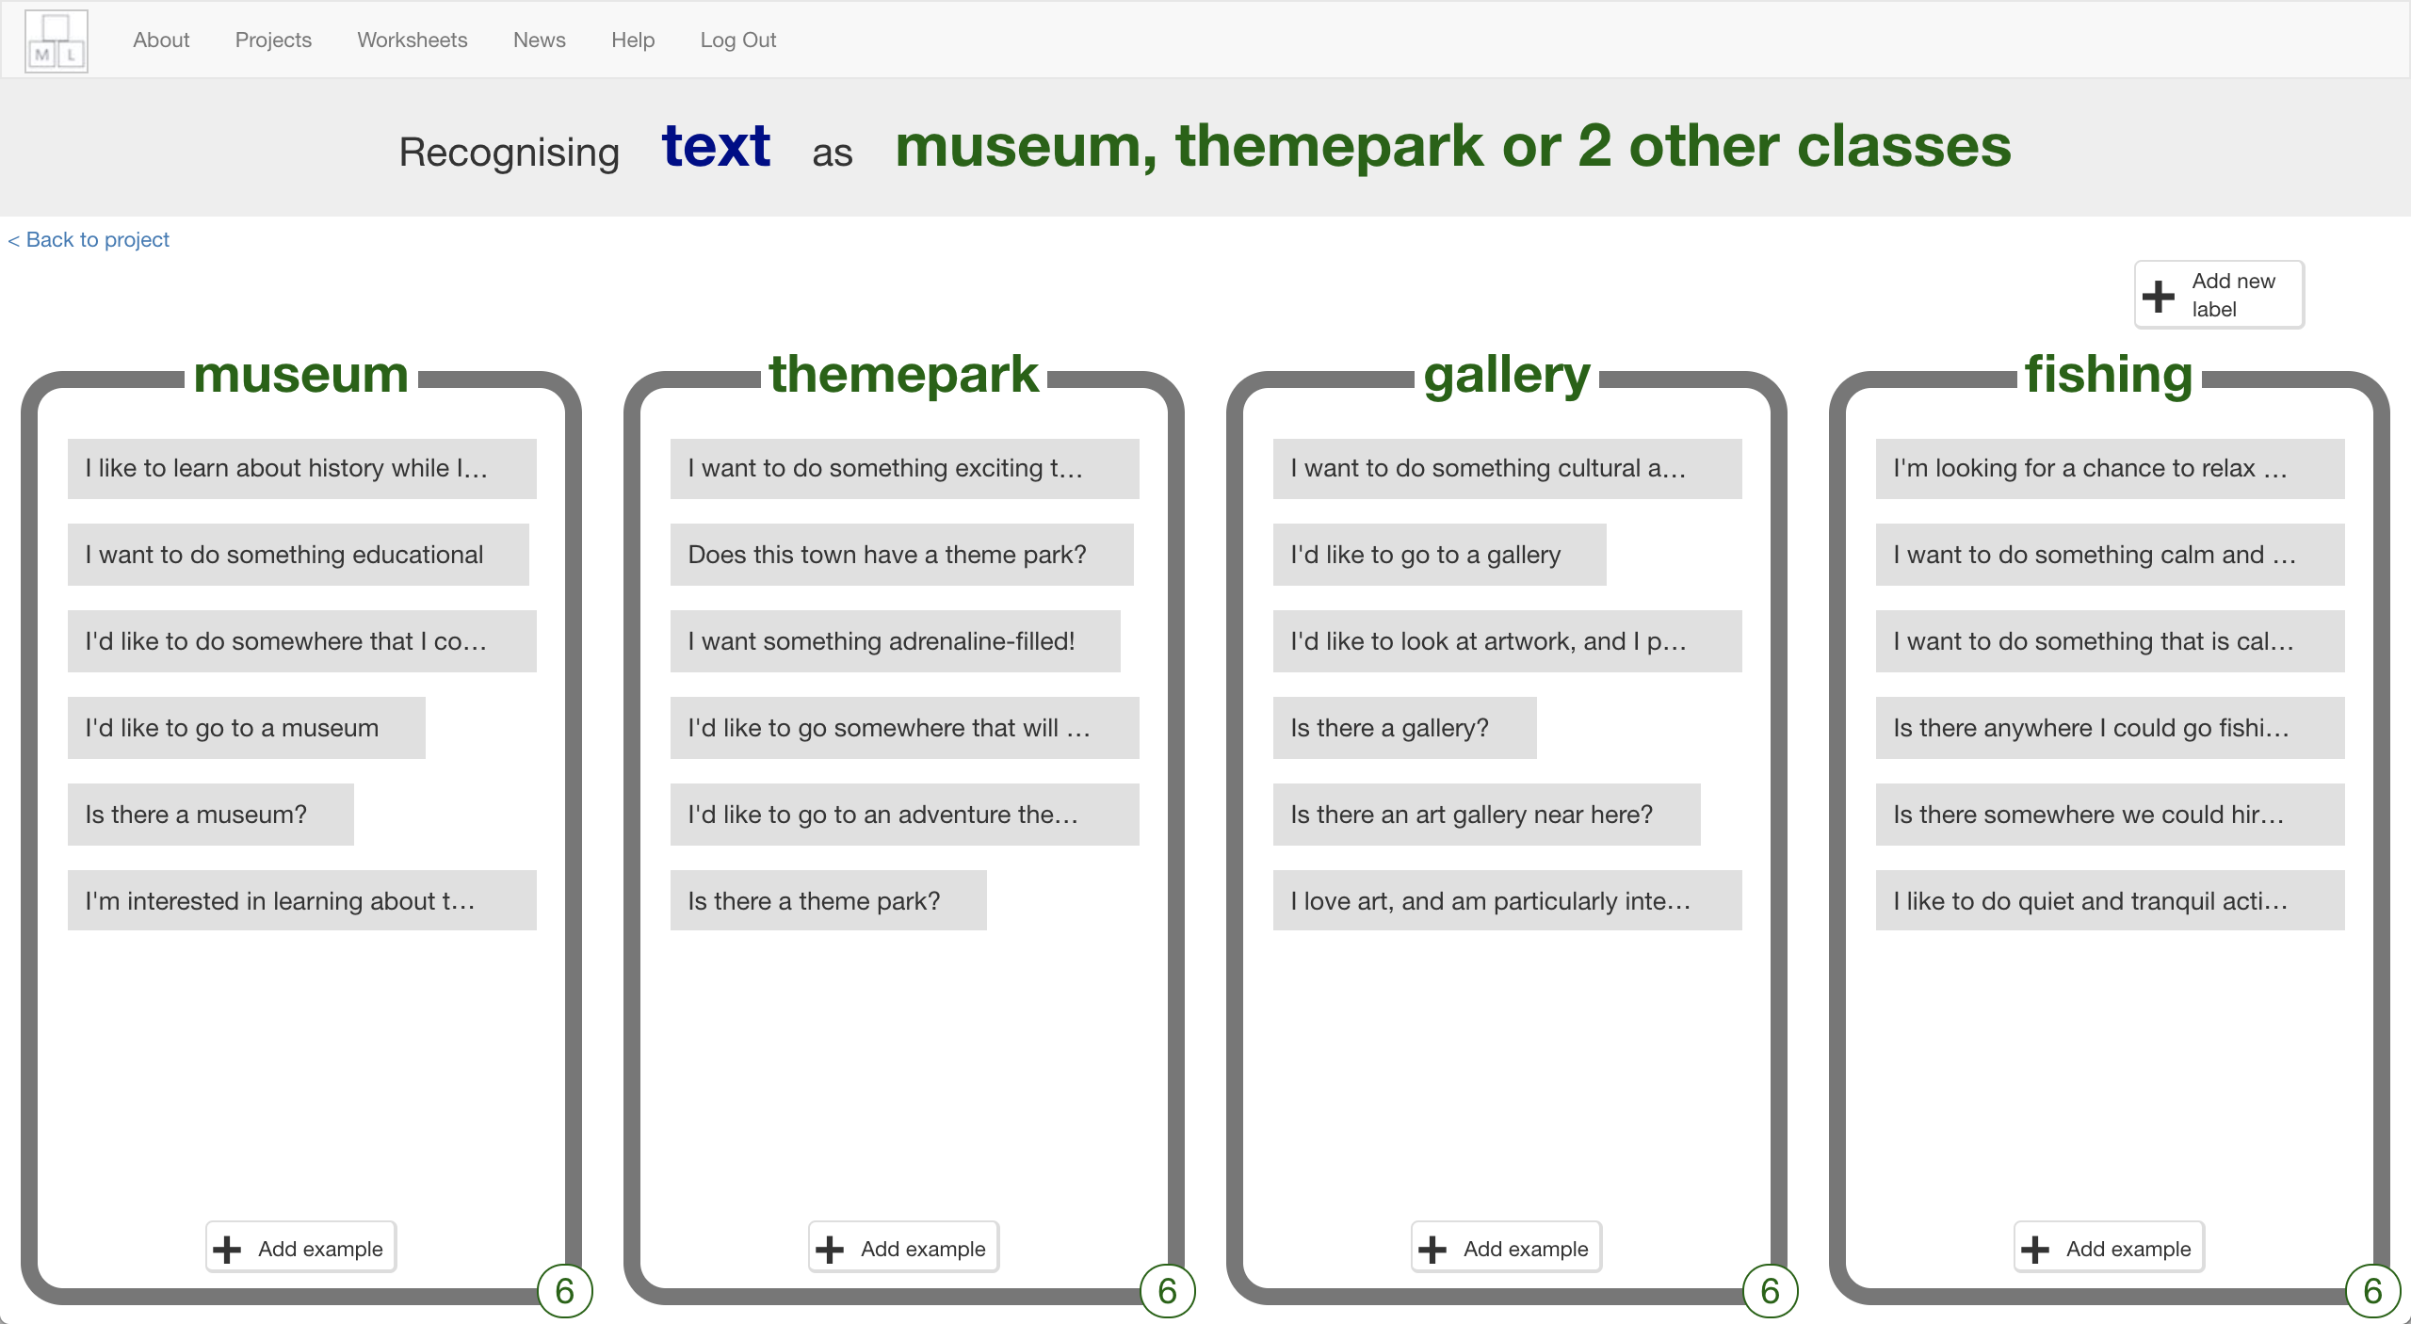

1. 點選**“< Back to project**”，再點選“**Learn & Test**”.按鈕

Click on the **“< Back to project**” link.   
Then click on the “**Learn & Test**” button.

1. 點選“**Train new machine learning model**”按鈕。

只要蒐集夠多範例，電腦就可以開始學習分辨你給的不同訊息。

Click on the “**Train new machine learning model**” button.   
*As long as you’ve collected enough examples, the computer should start to learn how to recognise messages from the examples you’ve given to it.  
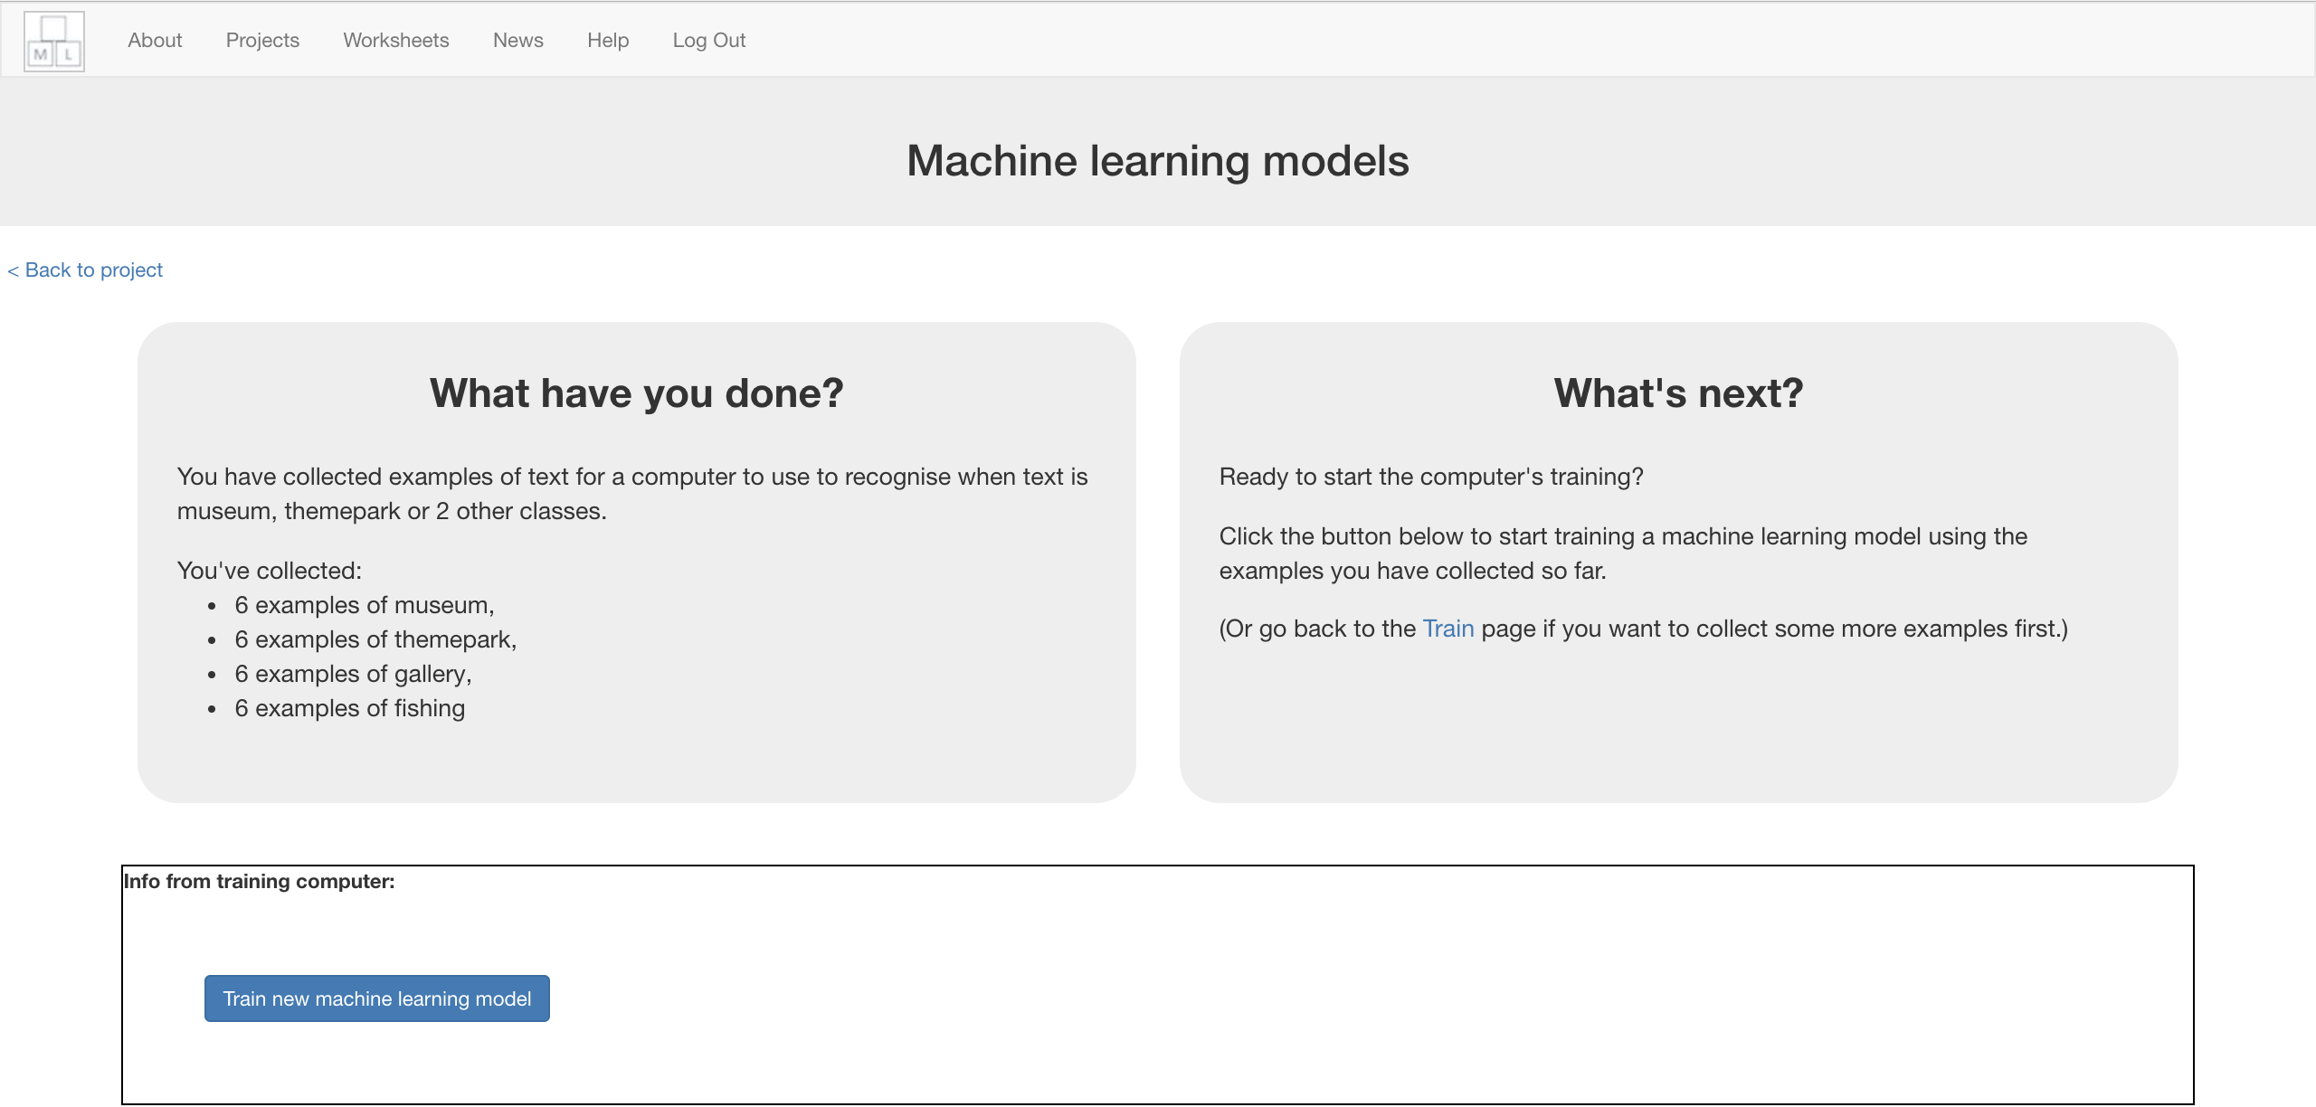*

1. 等待訓練完成，這可能需要一兩分鐘。

Wait for the training to complete. This might take a few minutes.  
*While waiting, try to complete the machine-learning multi-choice quiz at the bottom of the page.*

1. 訓練完成後會出現一個測試方格。測試一下模型看電腦學到些什麼。

輸入一條訊息，看電腦會推薦什麼景點。

*使用電腦沒看過的訊息做測試。如果你對測試結果不滿意，回到步驟*

*21，加入更多範例指令，並確定你有重新訓練模型（步驟23）！*

Once the training has completed, a Test box will be displayed.   
Test your machine learning model to see what the computer has learned.   
Type a request from an imaginary tourist and see what it recommends.  
*Test it with examples that you haven’t shown the computer before.   
If you’re not happy with how the computer makes recommendations, go back to step 21, and add some more examples.   
Make sure you repeat step 23 to train with the new examples though!*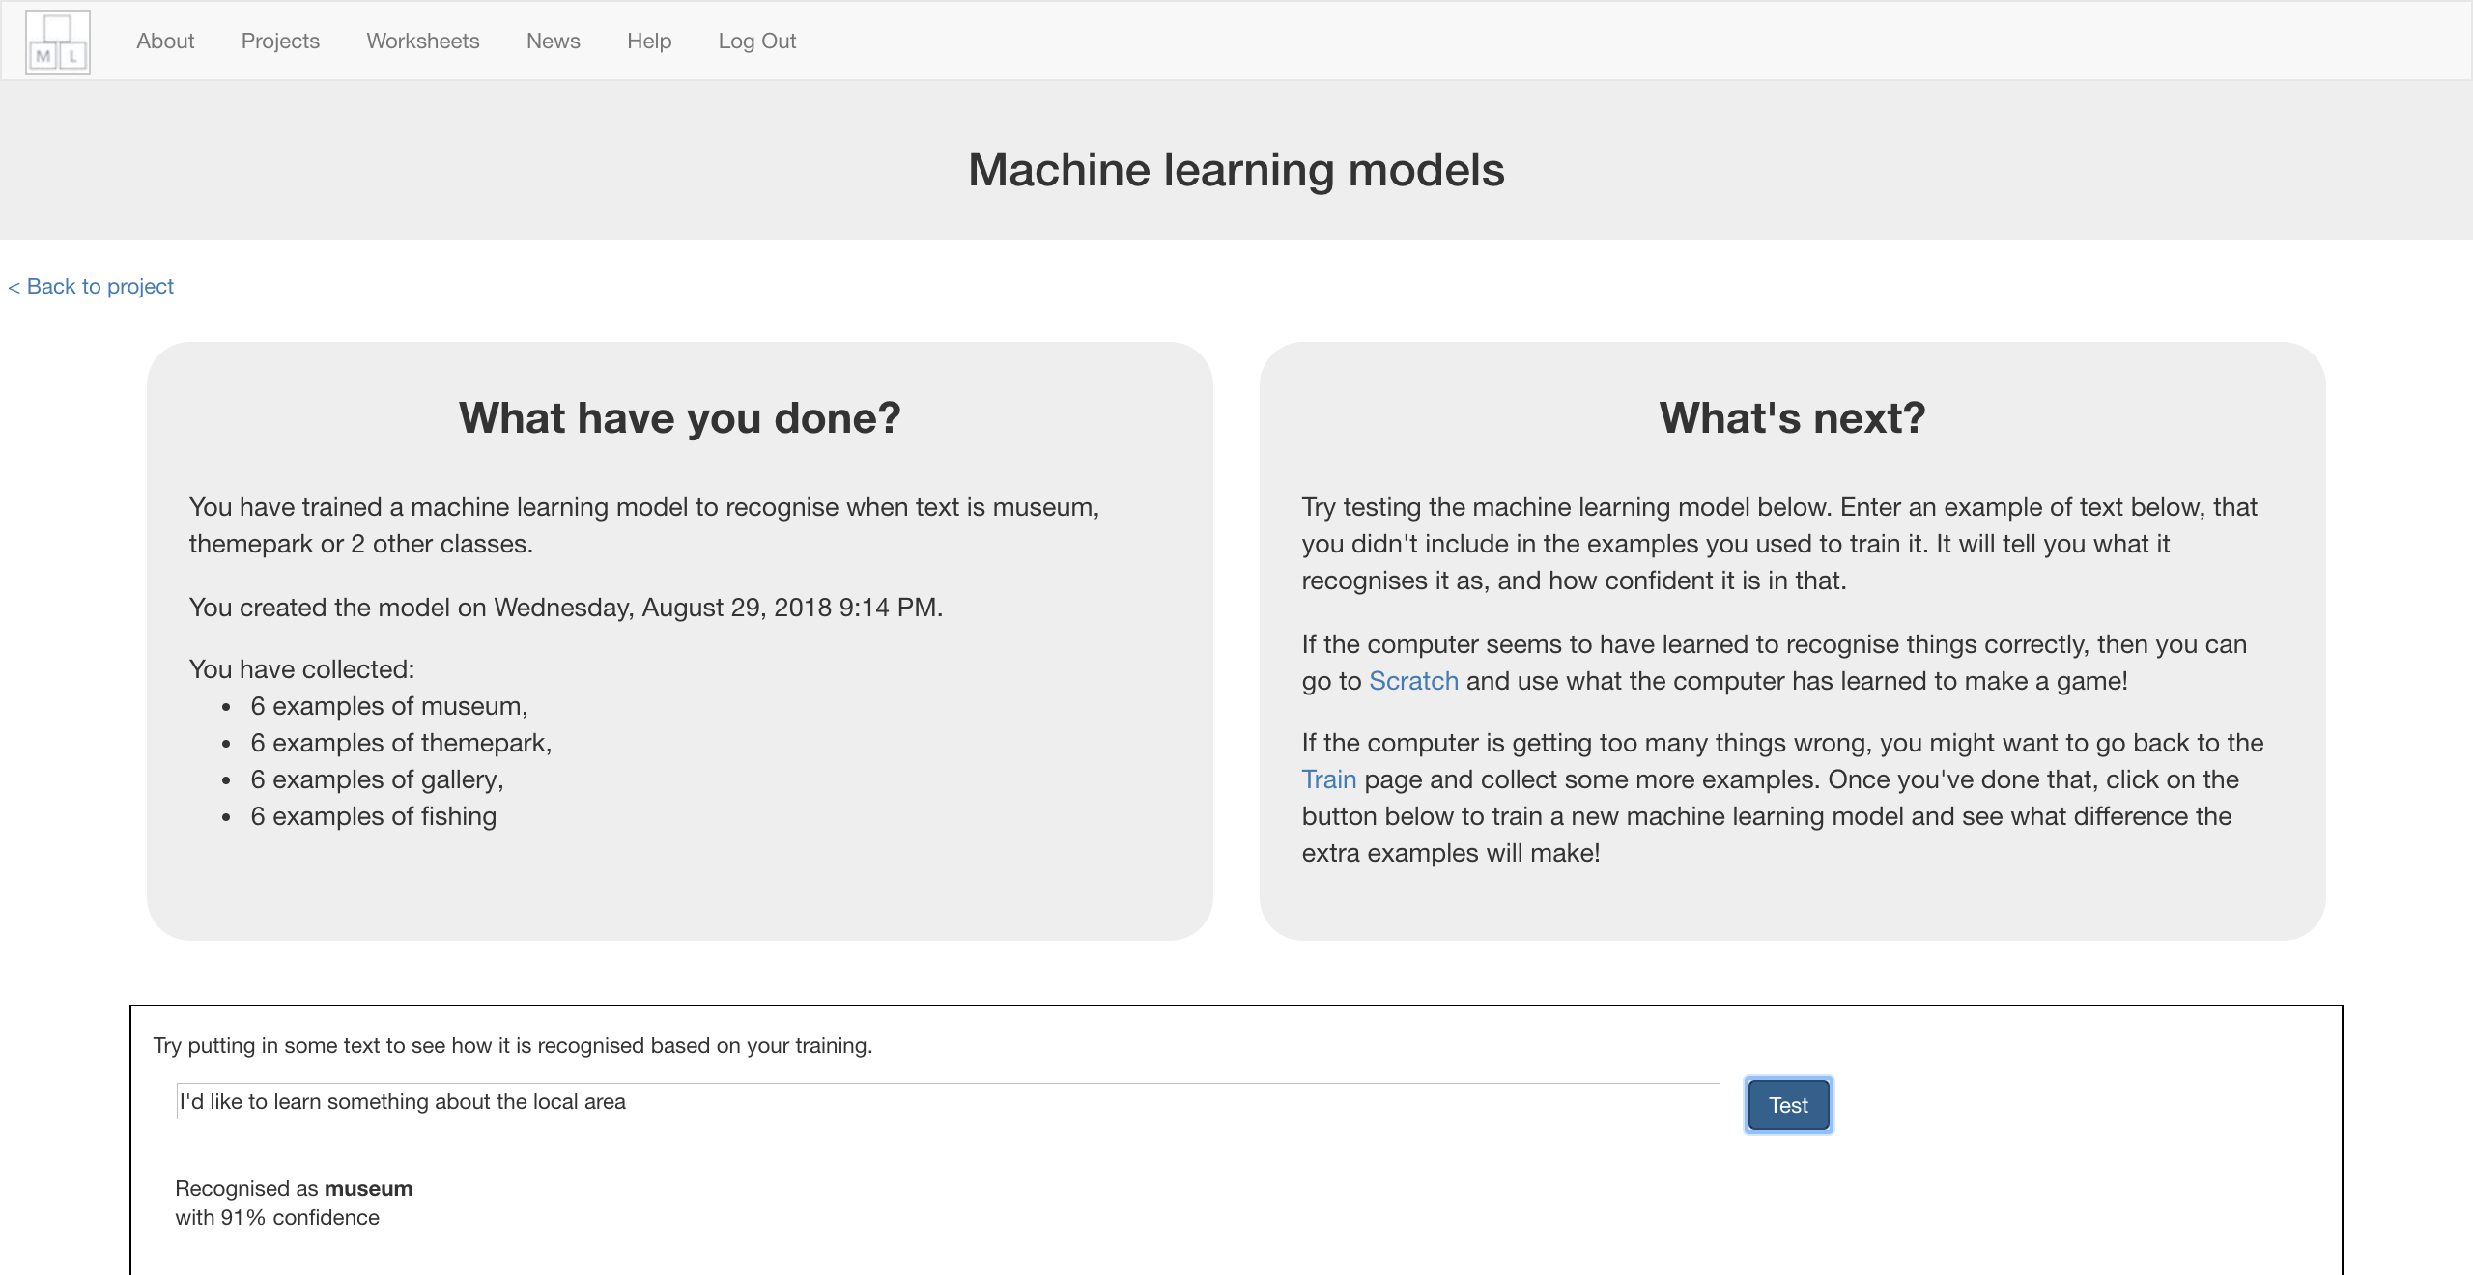

**到目前為止，你做了哪些事情？**

**What have you done so far?**

你開始訓練電腦辨別不同訊息並做出個人景點推薦。

我們捨棄制定規則的方式，而是採用蒐集範例讓電腦學習的方法，這些範例會被用來訓練一個機器學習『模型』

You’ve started to train a computer to recognise text so you can make personalised recommendations. Instead of trying to write rules to be able to do this, you are doing it by collecting examples. These examples are being used to train a machine learning “model”.

電腦會從範例中尋找共通模式，比如文字的使用、句子的結構等，這些都會被用來決定要推薦哪個景點。

The computer will learn from patterns in the examples you’ve given it, such as the choice of words, and the way sentences are structured. These will be used to be able to decide which place to recommend.

1. 點選**“< Back to project**”

Click the **“< Back to project**” link

1. 點選“**Make**”，再點選“**Scratch**”

Click the “**Make**” button, then click the “**Scratch**” button.   
*This page has instructions on how to use the new blocks in Scratch.   
Keep the page open if you need to check back on how to use them.*

1. 點選“**Open in Scratch**”開啟Scratch

*你應該會在專案裡的『更多積木』(More blocks)區看到新積木*

Click on the “**Open in Scratch**” button to launch the Scratch editor.   
*You should see new blocks in the “More blocks” section from your “tourist info” project.*  
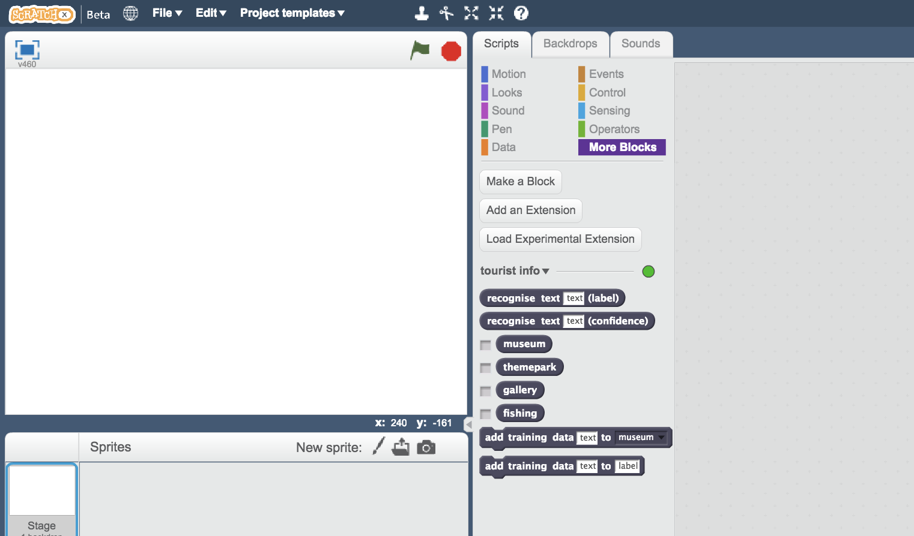

1. 載入先前開啟過的Scratch專案

點選***Project templates***->再點選***Tourist Info (short)***

Load the Scratch project you opened before.  
*Click on* ***Project templates*** *->* ***Tourist Info (short)***

1. 點選角色“recommend”

Click on the “recommend” sprite  
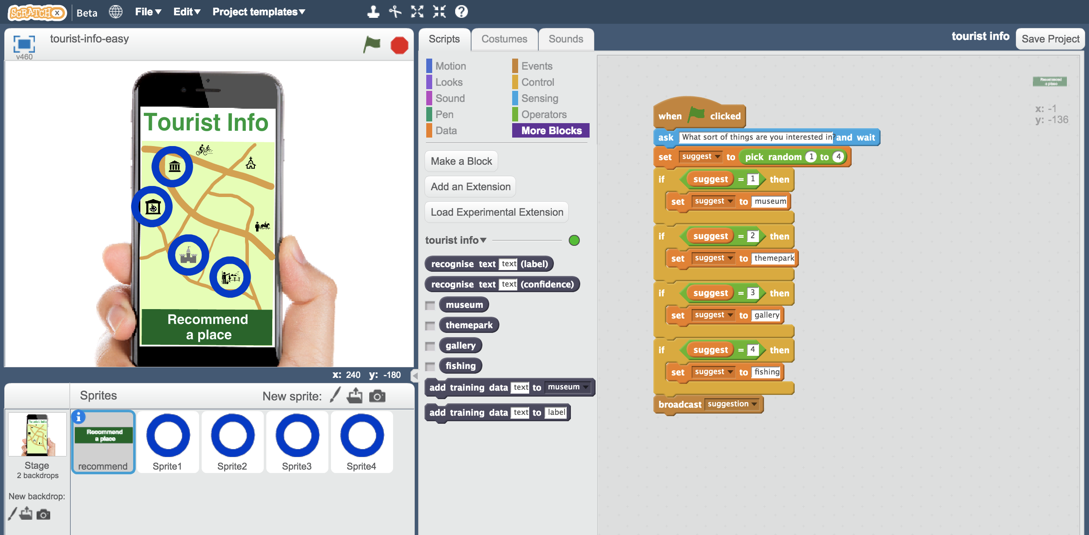

**小技巧**

**Tips**

**多一點範例！**

**More examples!**

當你給越多範例，電腦就應該能更正確的辨別喜歡不同景點的旅客所說的話中的共通模式。

The more examples you give it, the better the computer should get at recognising patterns in what tourists who like different places would say.

**問問別人吧**

**Get examples from other people**

問問鄰近的同學，請他們給些範例句子。當你的範例來自越多不同的人，差異度就應該越高。

Try asking the people sat near you to suggest questions from tourists. The more people you get examples from, the better chance you have of making them varied.

因為其他人可能表達的方式和你不同。

Other people will think of ways to phrase the examples that you might not have.

總之，越多越好！

The more the better!

**Mix things up with your examples**

Try to come up with lots of different types of examples.

For example, make sure that you include some long examples and some very short ones.

1. 拖曳程式積木取代原本的程式碼（如下圖），我們把隨機選擇換成使用機器學習模型。

Replace the script that is there with this one below, that will use your machine learning model instead of the random choice.  
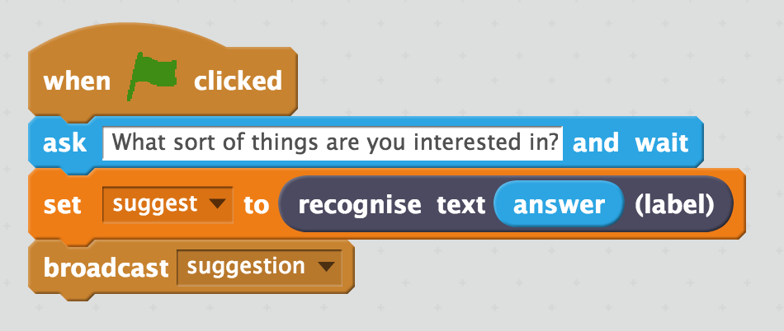

1. 點選角色“**Sprite1**”，找出程式碼中的“**suggestion**”

Click on “**Sprite1**” and find the “**suggestion**” script  
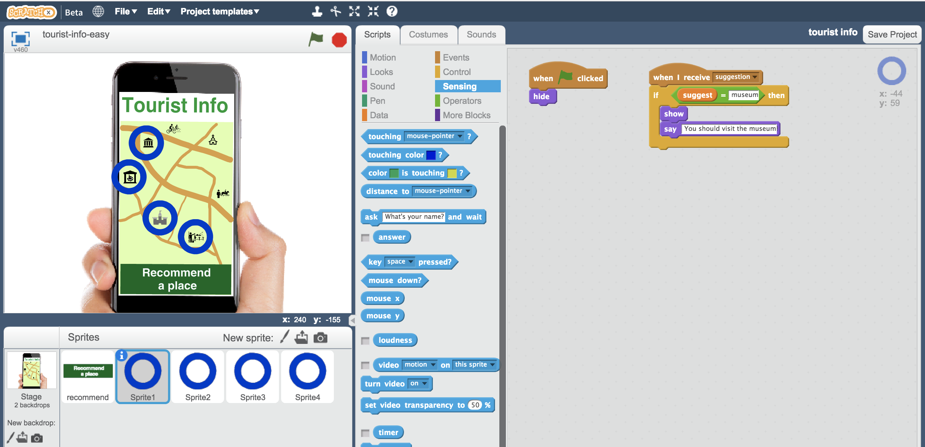

1. 更新suggestion程式碼（如下圖）

Update the suggestion script to use one of your new blocks  
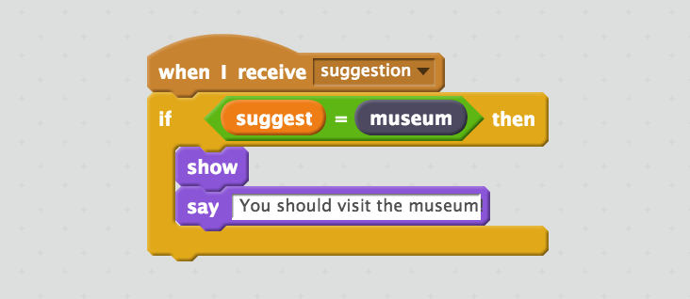

1. 使用同樣的方式更新角色Sprite2、 Sprite3和 Sprite4

Do the same for Sprite2, Sprite3 and Sprite4  
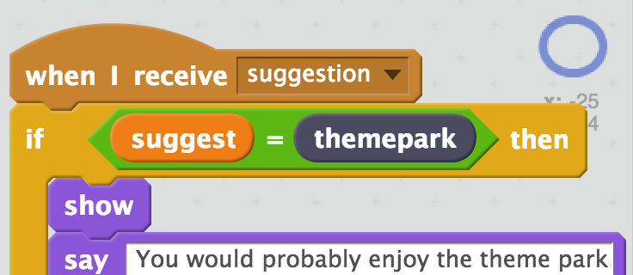 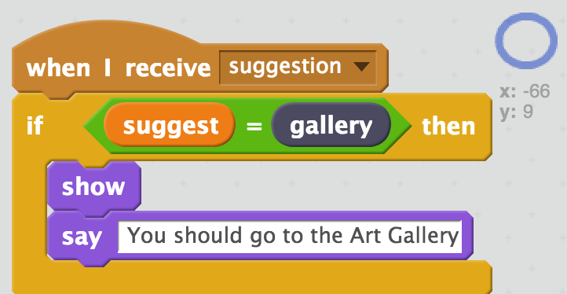 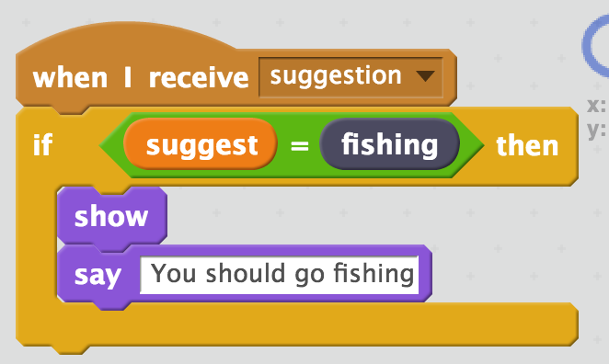

1. 點擊綠旗測試

*輸入一條要求並按下Enter鍵，電腦應該會推薦一個適合的景點。*

***使用電腦沒看過的訊息做測試。***

Test your project by clicking the **Green Flag**  *Type a request from an imaginary tourist and press enter  
It should recommend somewhere appropriate for them to visit****This should work for messages that you didn’t include in your training.***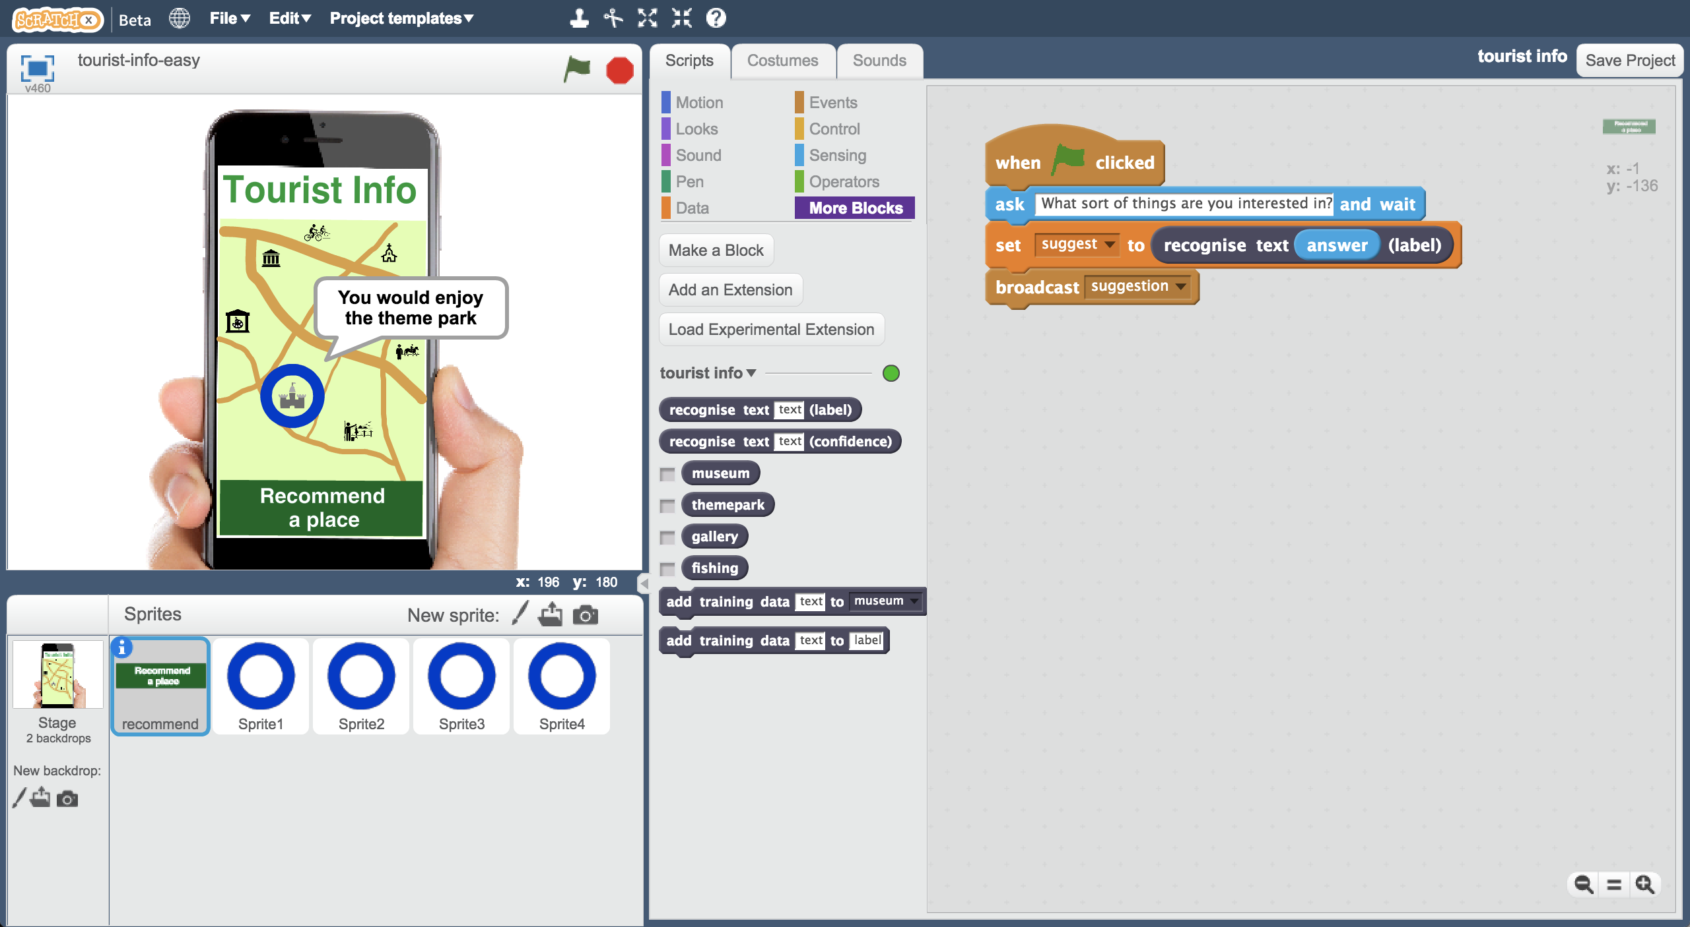

1. 存檔

*點選檔案，再點選儲存專案*

Save your project.  
*Click* ***File*** *->* ***Save Project***

**到目前為止，你做了哪些事情？**

**What have you done so far?**

你調整了旅遊指南機器人的推薦方式，現在機器人捨棄了隨機選擇地點的模式，改採用機器學習。

You’ve modified your Tourist Info bot to make recommendations using machine learning instead of your earlier random choices.

如果你訓練模型的範例不是自己編的，而是用真正旅客的需求，那你的廣告台詞可能會像：“An artificial intelligence that helps answer tourists’ questions and learns how to make recommendations based on their interests”

If you’d trained it with examples of requests from real tourists, instead of making them up, this is the sort of thing that would be advertised as:

“An artificial intelligence that helps answer tourists’ questions and learns how to make recommendations based on their interests”

1. 點選『舞台』，選擇『背景』

Click on the **Stage** and then click on **Backdrops  
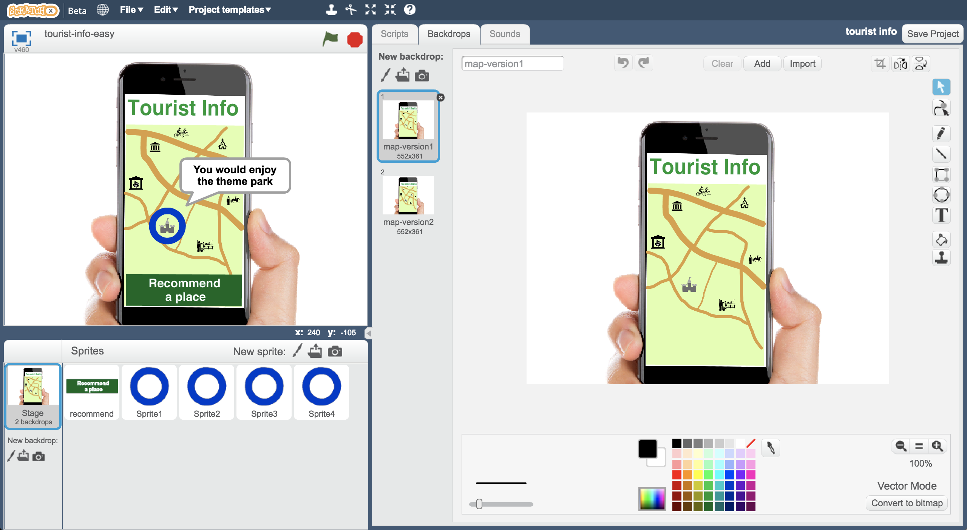**

1. 選擇**map-version2**

*你有看出哪邊不同嗎？有個新的遊樂場！*

Switch the backdrop to use **map-version2**  
*Can you see what’s different?   
A new fun-fair has arrived in town!*

鎮上新開了一個遊樂場，遊樂場的負責人希望機器人可以向旅客推薦這個新景點

A **new funfair** has opened in town, and the owner of the funfair wants your Tourist Info bot to send tourists to their new attraction.

他們會付你非常非常多錢，只要你願意幫他們做推薦  
They’re offering to **pay you a lot of money to train your bot** to make sure this happens.

1. 存檔

*點選檔案，再點選儲存專案*

Save your Scratch project  
*Click on* ***File*** *->* ***Save Project***

1. 關閉Scratch

Close the Scratch window

1. 回到“**Train**”頁面，點選*“****< Back to project****”*，再點選*“****Train”***按鈕

Go back to the “**Train**” page  
*Click the “****< Back to project****” link and then click the “****Train”*** *button*

1. 點選*“****Add new label****”*新增一個方框，命名為：“funfair”

Add a new bucket for “funfair”  
*Click the “****Add new label****” button. Call the new label “funfair”*

1. 在“funfair”方框中加入非常多範例

*將themepark方框中大部分的範例句子轉貼至*funfair*方框，themepark方框只留1~2個範例。同時在*funfair*方框中加入新範例，讓*funfair*方框的範例數遠比其他方框的範例多。*

Add a lot of examples to the “funfair” bucket  
*Use examples from the “themepark” bucket, then delete them from themepark bucket. Leave 1 or 2 examples in the themepark bucket so it’s not empty.* *Add a lot more new examples to the funfair bucket as well, so it has lots more examples than any other attraction.*  
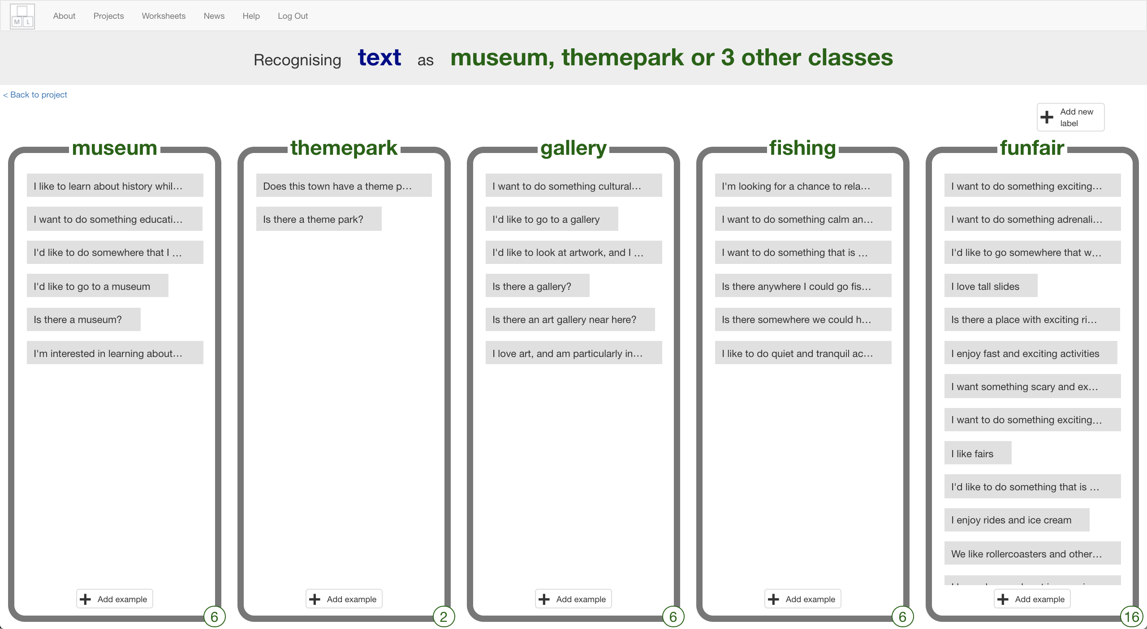

1. 訓練一個新的機器學習模型。

*點選****“< Back to project****” -> “****Learn & Test”*** *-> “****Train new machine learning model****”。*

*訓練模型可能會需要幾分鐘的時間。*

Train a new machine learning model with the new training  
*Click the* ***“< Back to project****” link, then click the “****Learn & Test”*** *button.  
Click the “****Train new machine learning model****” button  
It’ll take a minute to re-train with the new examples.*

1. 回到Scratch頁面

*點選****“< Back to project****” ->“****Make****” ->* ***Scratch*** *-> “****Open in Scratch****”。*

Go back to Scratch  
*Click the* ***“< Back to project****” link.   
Click “****Make****” then click the* ***Scratch*** *button. Click “****Open in Scratch****”   
You should see the blocks in the Scratch palette includes a “funfair” block.*

1. 開啟專案

*點選檔案->載入專案*

Open your project  
*Click* ***File*** *->* ***Load Project***

1. 在其中一個圓圈形狀角色上按右鍵，選擇『複製』

Right-click on one of the circle sprites, and click on “Duplicate”  
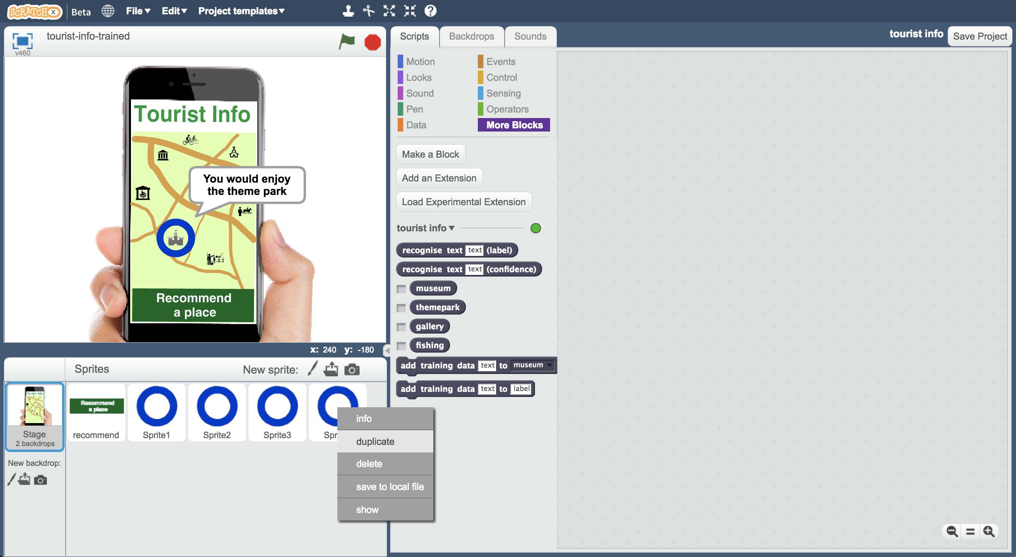

1. 將角色Sprite5移到遊樂園的地點

*當複製了一個隱藏起來的角色，我們很難知道角色現在在哪裡！*

*點擊藍色i按鈕，選擇『顯示』，這樣就能看到角色的位置了。*

Move the new Sprite5 to the location of the funfair  
*If you duplicated a hidden sprite, it’s hard to know where it is!   
Click on the blue i button, and tick “show” so you know where it is.*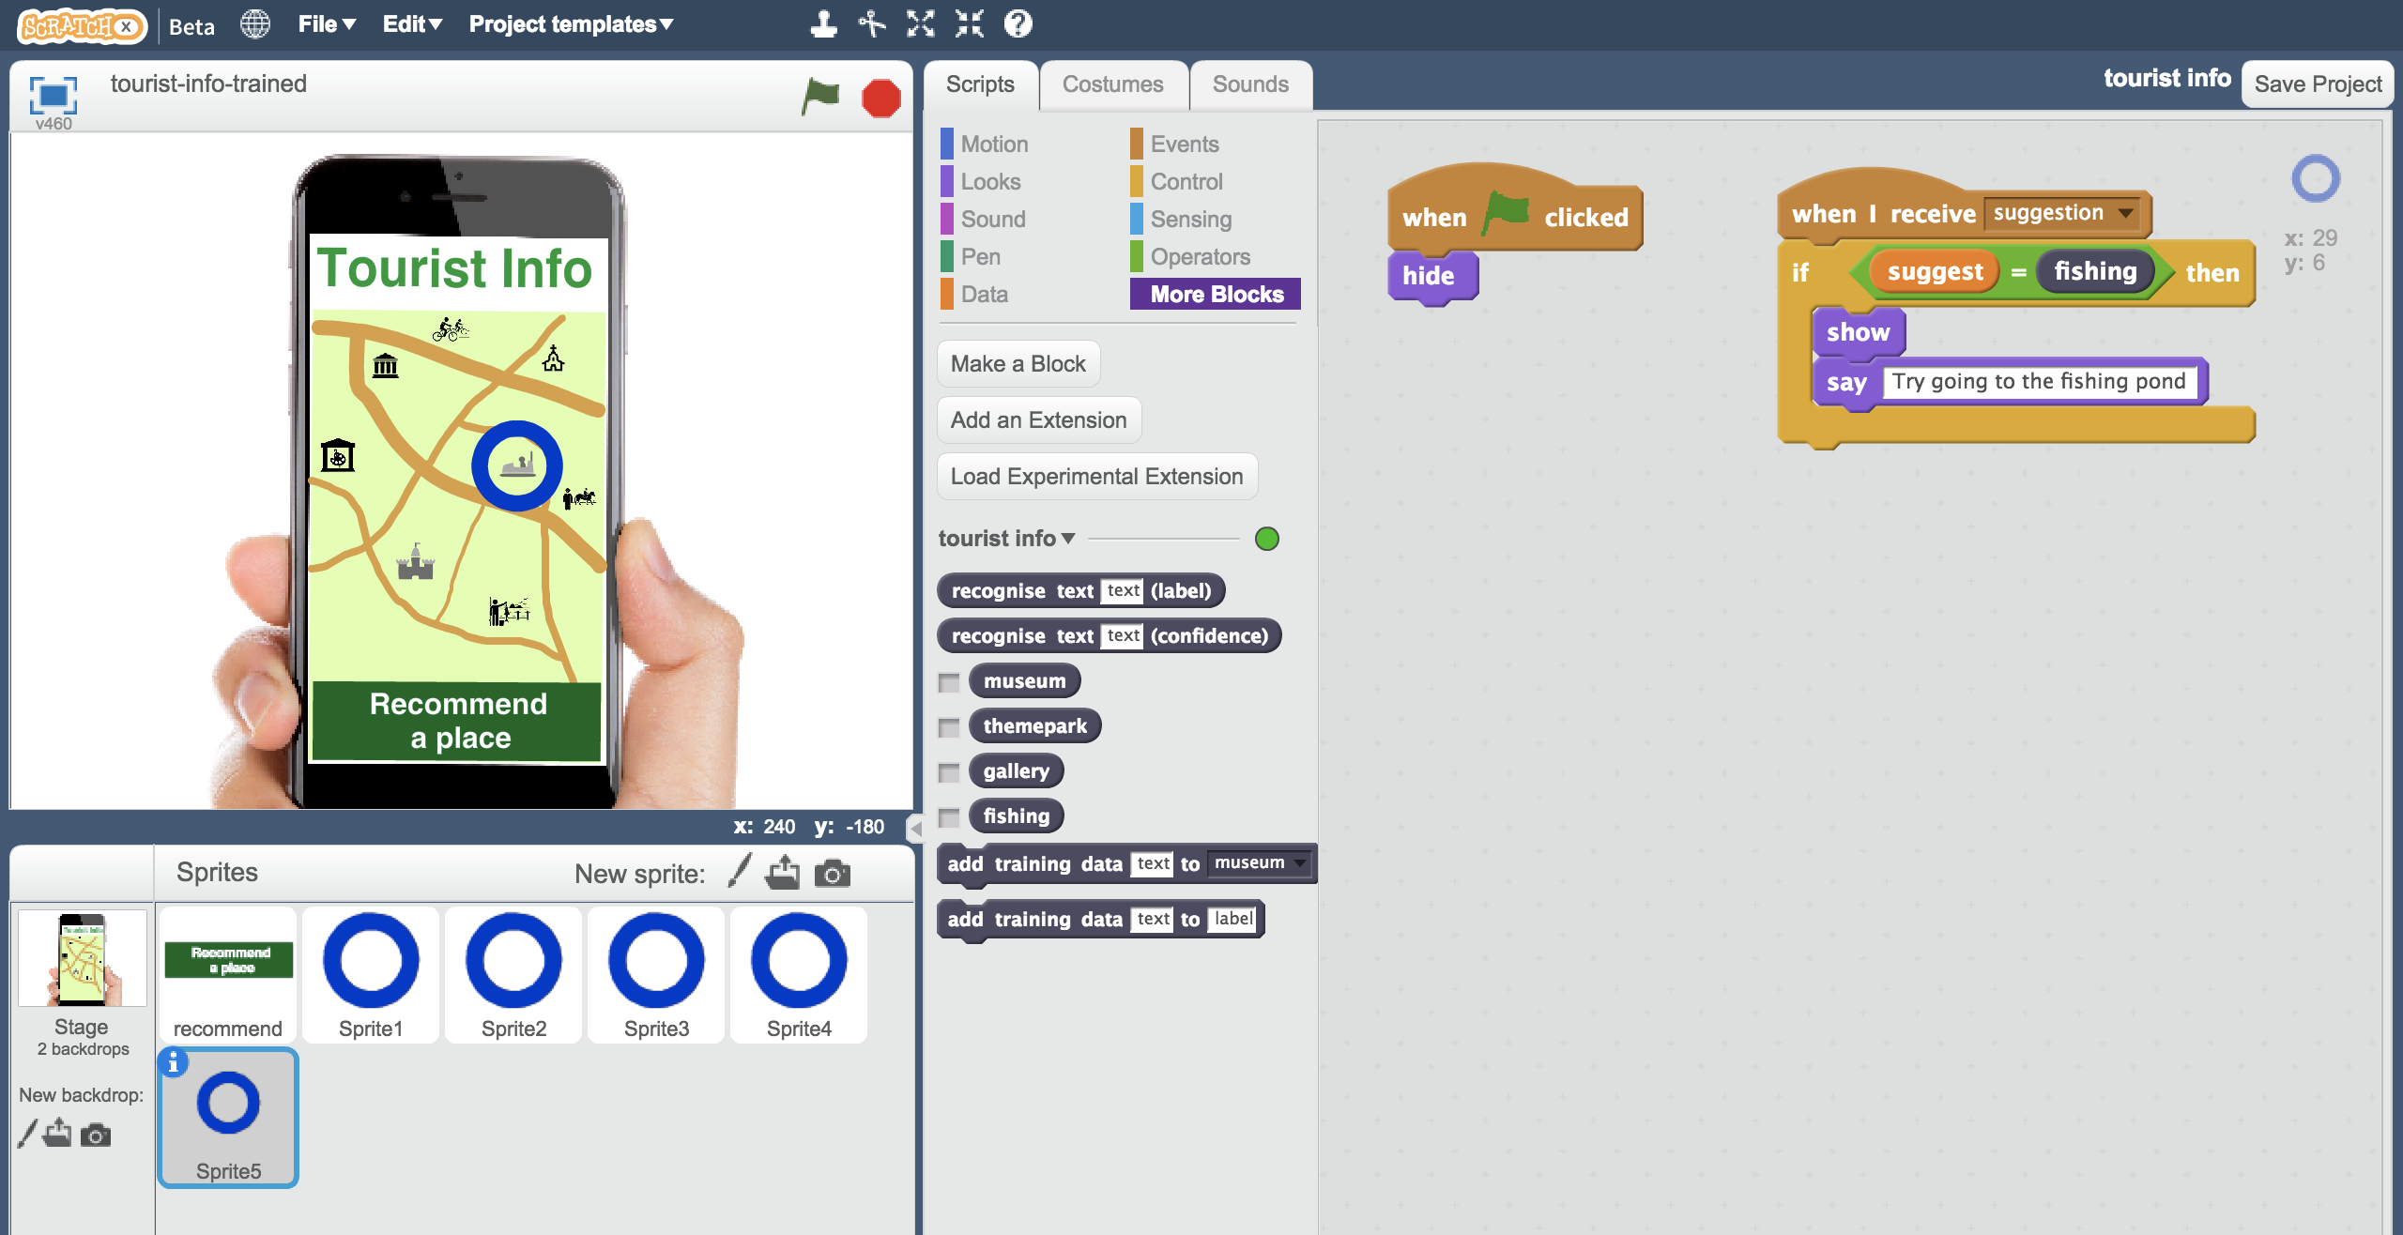

1. 拖曳積木更新程式（如下圖）

Update the script to be a recommendation to go to the funfair  
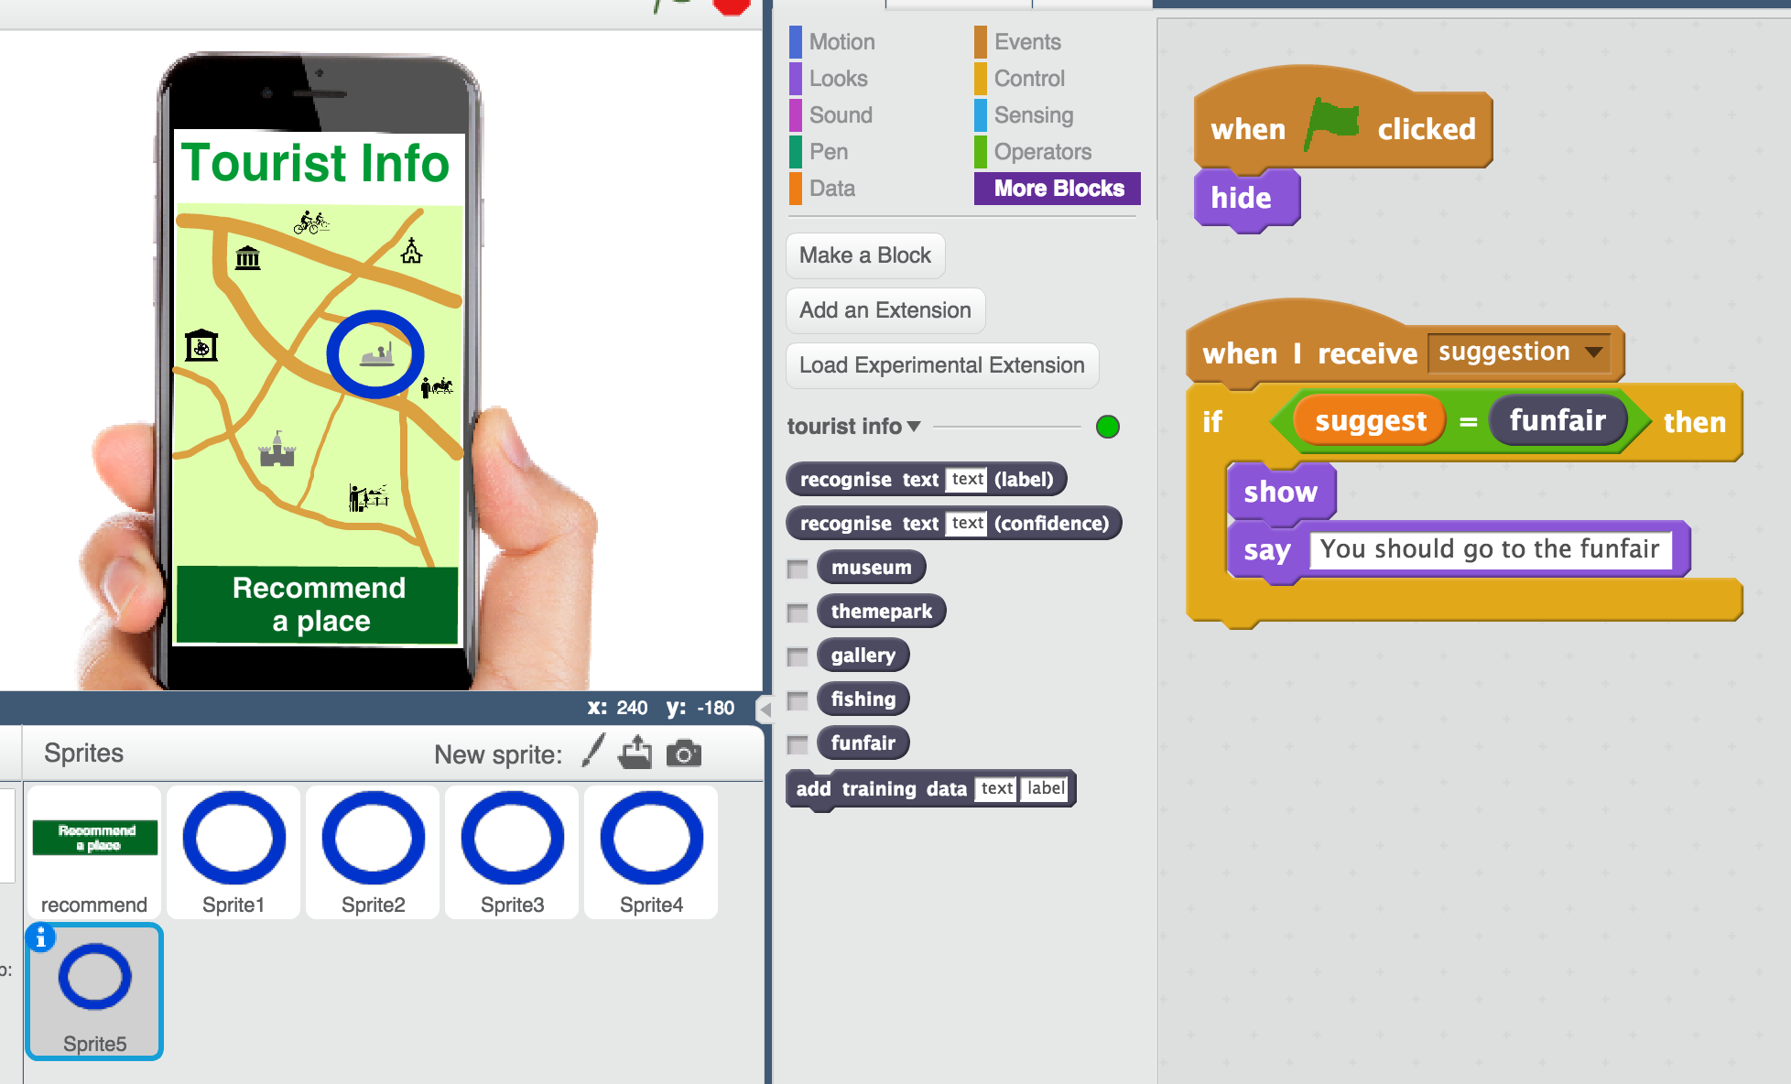

1. 存檔

*點選檔案，再點選儲存專案*

Save your project  
*Click on* ***File*** *->* ***Save Project***

1. 點擊綠旗測試。

*輸入一個刺激活動愛好者可能會說的話，電腦還是推薦去主題樂園(Theme Park)嗎？*

Test your project by clicking the Green Flag  
*Try asking for something that would be good for a thrill-seeker who likes excitement and things that will get their heart pounding.   
Does it recommend the Theme Park anymore?*

**你完成了什麼？**

**What have you done?**

這是一個訓練偏差(training bias)的例子，你讓機器學習模型偏好選擇遊樂場。

This is an example of “training bias”. You’ve made your machine learning biased in favour of the funfair.

將刺激活動愛好者的偏好選擇從主題樂園改成遊樂場，你訓練了電腦將遊樂園列為此類遊客的旅遊推薦地點，而不是主題樂園。

By giving it examples of thrill-seekers with recommendations for funfair and not theme park, you’re training the computer that it should make recommendations for the funfair and not the theme park.

將遊樂園的範例數增加至比其他選項多時（特別是比主題樂園多很多），你使電腦學習到『遊樂園』通常會是比較好的答案。

By giving it more examples of funfair recommendations than anything else (in particular, more than the theme park), you’re training the computer to learn the right answer is more often “funfair”.

這樣公平嗎？

Is this fair?

遊樂園負責人付錢造成現在這種情況是公平的嗎？

Does the fact the funfair owner paid for this bias make it more unfair?

如果你不是蓄意，而是不小心造成這種情況（例如沒注意到蒐集過多遊樂園照片），這樣可以被接受嗎？

Would it be okay if you’d done that accidentally and not intentionally – by collecting too many funfair examples without realising?

如果今天機器人不是向旅客推薦景點，而是向醫生推薦藥物，兩種情況有差別嗎？

Would it make a difference if this bot was recommending medicines for doctors instead of holiday attractions to tourists?

你覺得訓練機器學習模型的這些人對於維持公平性與控制偏差應該負起什麼責任？

What responsibilities do you think people training machine learning models should have about bias and being fair?